cBioPortal Data Loading Steps

12/02/2024 Yizhen Chen

Table of Contents
Data Loading Steps Overview 3
Step 1: System Environment Setup 3
Build and Run cBioPortal Application 3
Software Requirements 3
Build System 3
Build cBioPortal Core environment (data loading script) 4
Load-prepared data 4
Create database 4
Download prepared gene panel data 5
Load custom data 5
Prepare CCDI data 5
Download CCDI Hub Data 5
Reformatted CCDI hub data 5
Cancer Study 5
Cancer Type 6
Clinical Data-meta-file-sample 7
Load Study data files 9

Data Loading Steps Overview

- Setup System Environment
- Load Seed Gene data
- Load custom data

Step 1: System Environment Setup

Build and Run cBioPortal Application

Software Requirements
Java version 21
MySQL
Apache Maven

Build System
Get the latest code
git clone https://github.com/cBioPortal/cbioportal.git
cd cbioportal
git checkout master
Prepare the global configuration file
cd src/main/resources
cp application.properties.EXAMPLE application.properties

update the database setting in application.proterties file
make sure the datasource.url contains
useSSL = false;
allowPublicKeyRetrieval=true
allowLoadLocalInfile=true

# database
spring.datasource.url=jdbc:mysql://127.0.0.1:3306/cbioportal?useSSL=false&allowPublicKeyRetrieval=true&allowLoadLocalInfile=true
spring.datasource.username=cbio_user
spring.datasource.password=123456
spring.datasource.driver-class-name=com.mysql.jdbc.Driver
spring.jpa.database-platform=org.hibernate.dialect.MySQL5InnoDBDialect

Build with Maven
mvn -DskipTests clean install

Run the cBioProtal
java -jar target/cbioportal-exec.jar
java -jar target/cbioportal-exec.jar -Dauthenticate=false

Build cBioPortal Core environment (data loading script)
Build cbioPortal loading script
git clone https://github.com/cBioPortal/cbioportal-core.git
cd cbioportal-core
git checkout main
Configure the cbioportal-core
Create application.properties, save to cbioportal-core src/main/resource
Content of application.properties is database connection, same with cBioportal

Set the PORTAL_HOME environment variable
PORTA_HOME point to cbioportal application directory
export PORTAL_HOME=/Users/johndoe/cbioportal

Compile and build
mvn -DskipTests clean install

Create Python environment
Create a Python virtual environment (first-time setup):
python -m venv .venv
Activate the virtual environment:
source .venv/bin/activate
Install required Python dependencies (first-time setup or when dependencies have changed):
pip install -r requirements.txt

Load-prepared data

Create database
Use the script to create database.
https://github.com/cBioPortal/cbioportal/blob/master/src/main/resources/db-scripts/cgds.sql

Download prepared gene panel data
Follow the instruction here
https://github.com/cBioPortal/datahub/tree/master/seedDB

Load custom data

Prepare CCDI data
The CCDI Hub contains data elements such as studies, samples, and participants, which can be formatted to align with cBioPortal's file structure, including Cancer Study, Cancer Type, and Clinical Data. As of March 2016, the Clinical Data file in cBioPortal has been divided into two separate files: a patient clinical file and a sample clinical file.
CCDI data can be downloaded from the Hub and reformatted to meet the requirements of cBioPortal.

Download CCDI Hub Data
Download the descriptive information about a study from CCDI explorer page.
https://ccdi.cancer.gov/explore

Reformatted CCDI hub data
Case study on Molecular Characterization Initiative (MCI) Study

Cancer Study
Name: meta_study.txt
This file contains metadata about the cancer study. The file contains the following fields:
field | value | map to CCDI MODEL | comment
type_of_cancer | MIXED | N/A | The cancer type abbreviation, e.g., "brca". This should be the same cancer type as specified in the meta_cancer_type.txt file, if available. The type can be "mixed" for studies with multiple cancer types.
cancer_study_identifier | phs002790 | Study.study_id
description | ****** | Study. study_description
add_global_case_list | TRUE |  | set to 'true' if you would like the "All samples" case list to be generated automatically for you.

Cancer Type
Name: meta_cancer_type.txt
If the type_of_cancer specified in the meta_study.txt does not yet exist in the type_of_cancer database table, a meta_cancer_type.txt file is also mandatory.
The file is comprised of the following fields:
- genetic_alteration_type: CANCER_TYPE
- datatype: CANCER_TYPE
- data_filename: your datafile

field | value | map to CCDI MODEL | comment
genetic_alteration_type | CANCER_TYPE | N/A
datatype | CANCER_TYPE | N/A
data_filename | cancer_type.txt | N/A

Name: cancer_type.txt
The file is comprised of the following columns in the order specified:
- type_of_cancer: The cancer type abbreviation, e.g., "brca".
- name: The name of the cancer type, e.g., "Breast Invasive Carcinoma".
- dedicated_color: CSS color name of the color associated with this cancer study, e.g., "HotPink". See this list for supported names, and follow the awareness ribbons color schema. This color is associated with the cancer study on various web pages within the cBioPortal.
- parent_type_of_cancer: The type_of_cancer field of the cancer type of which this is a subtype, e.g., "Breast". ℹ️ : you can set parent to tissue, which is the reserved word to place the given cancer type at "root" level in the "studies oncotree" that will be generated in the homepage (aka query page) of the portal.

It is a txt file and the content is delimited by tab
Here is example: brca<TAB>Breast Invasive Carcinoma<TAB>HotPink<TAB>Breast

I would recommend use Excel sheet to fill in the content and save as Tab delimited Text to avoid any formatting issues.

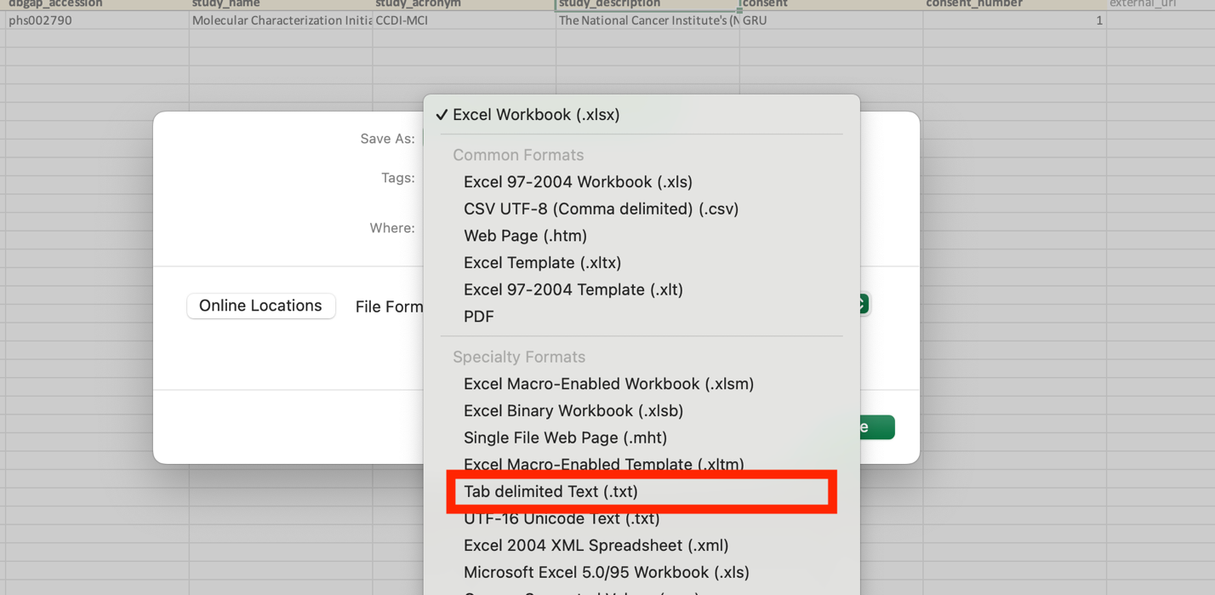

Clinical Data-meta-file-sample
The clinical file is split into a patient clinical file and a sample clinical file.
The sample file is required, whereas the patient file is optional.

Sample meta file

field | value | map to CCDI MODEL | comment
cancer_study_identifier | phs002790 | N/A | Referes to cancer_study_identifier on meta_study file
genetic_alteration_type | CLINICAL | N/A
dataType | SAMPLE_ATTRIBUTES | N/A
data_filename | data_clinical_sample.txt | N/A

Sample data file
Name: data_clinical_sample.txt
Similar to the cancer_type.txt and content is delimited by tab
You can put any sample data you like to the data_clinical_sample.

Clinical sample columns
The file containing the sample attributes has two required columns:
- PATIENT_ID (required): A patient ID. This field can only contain numbers, letters, points, underscores and hyphens.
- SAMPLE_ID (required): A sample ID. This field can only contain numbers, letters, points, underscores and hyphens.

The first four rows of the clinical data file contain tab-delimited metadata about the clinical attributes. These rows have to start with a '#' symbol. Each of these four rows contain different type of information regarding each of the attributes that are defined in the fifth row:
- Row 1: The attribute Display Names: The display name for each clinical attribute
- Row 2: The attribute Descriptions: Long(er) description of each clinical attribute
- Row 3: The attribute Datatype: The datatype of each clinical attribute (must be one of: STRING, NUMBER, BOOLEAN)
- Row 4: The attribute Priority: A number which indicates the importance of each attribute
- Row 5: The attribute name for the database: This name should be in upper case.
- Row 6: This is the first row that contains actual data.

Example
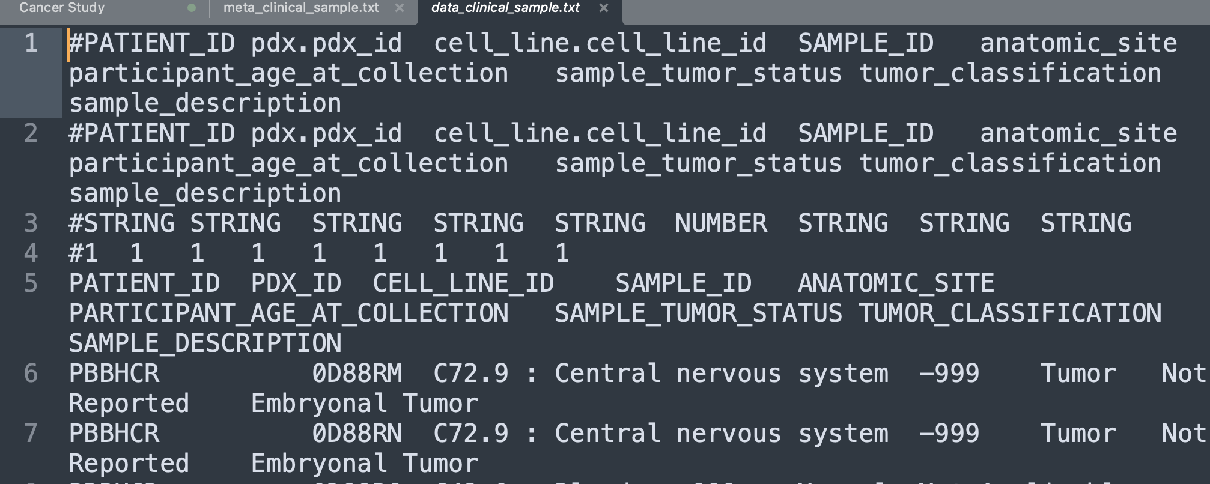

Patient data file (Participant data)

Name :data_clinical_patient.txt
Similar to the sample data file, you can include any participant data in the data_clinical_patient file, following the same structure as the sample data file.

Clinical patient columns
The file containing the patient attributes has one required column:
- PATIENT_ID (required): a unique patient ID. This field allows only numbers, letters, points, underscores and hyphens.

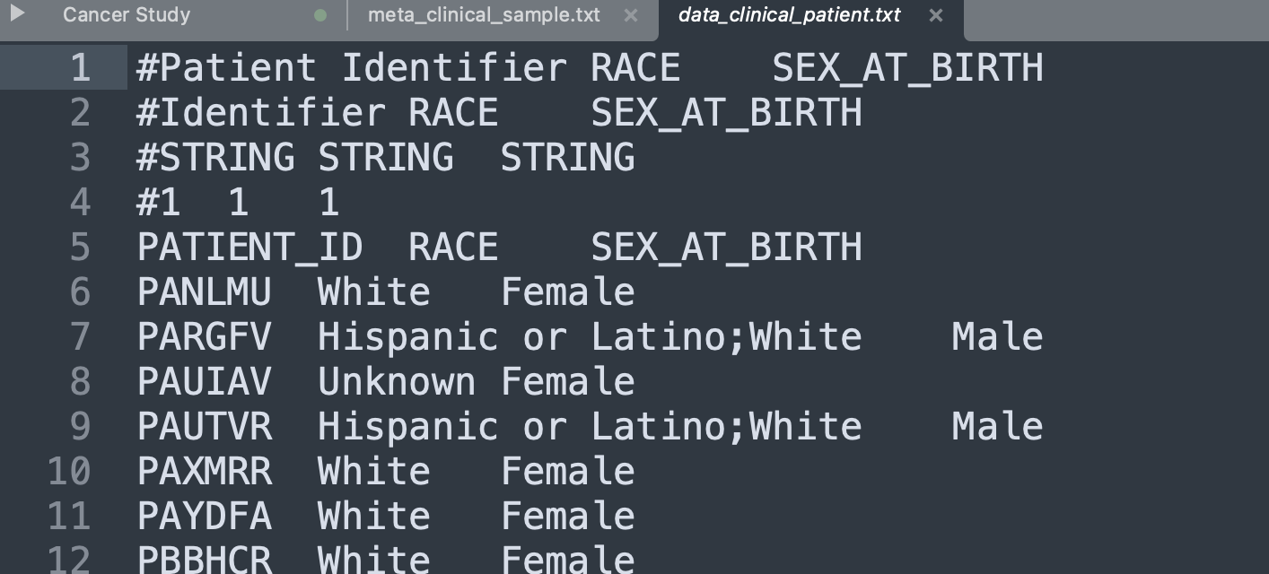

Load Study data files
To import the study:
cd cbioportal-core/src/main/scripts/importer
and then run the following command:
./metaImport.py -s ./data_files_dir/ -n -o

After loading the study data, please restart the app

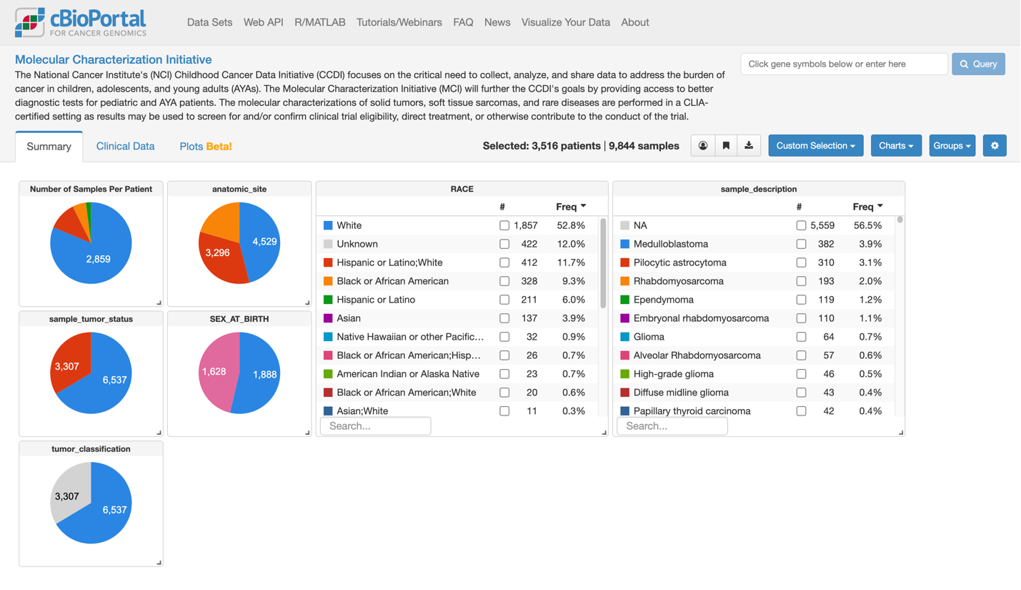

Reference:
Document https://docs.cbioportal.org/deployment/deploy-without-docker/software-requirements/
GIthub:
https://github.com/cBioPortal/cbioportal
https://github.com/cBioPortal/cbioportal-core

